**Disciplined Entrepreneurship Workbook**

# Step 18: Map the Sales Process to Acquire a Customer

## WHAT IS STEP 18, Map the Sales Process to Acquire a Customer?

Visually show how you will create and fulfill demand for your product over the short term, the medium term, and the long term.

## WHY DO WE DO THIS STEP AND WHY DO WE DO IT NOW?

The sales process is a critical input to estimating the Cost of Customer Acquisition (COCA) in the next step, Step 19. The sales process, including selecting your sales channels, will allow you to understand the unit economics of your product and then adjust accordingly to increase profitability. You can intelligently map the sales process now that you have an estimate from Step 17 of the LTV, which helps indicate which sales methods are affordable and practical for your startup.

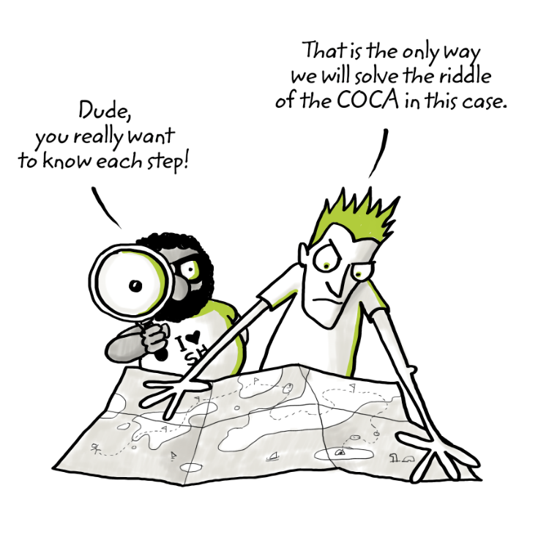

*Figuring out how to generate demand and to fulfill it with a sales channel strategy is your next key decision.*

## By the Book

See pages 195-201 of *Disciplined Entrepreneurship* for base knowledge on this step.

See pages 201-202 of *Disciplined Entrepreneurship* for examples of how different companies and teams have addressed this step.

## Process Guide

Now that you have a general range for what the LTV is going to be for your product, you can now start to focus on your sales strategy. In *Disciplined Entrepreneurship* I chose not to call it a channel strategy because the decision should be more thoughtful than a typical channel strategy, but most people still recognized it as a channel strategy. I won’t fight this nomenclature too much, but I think of it as a “channel strategy plus.” It is a dynamic go-to-market strategy to both create demand and then fulfill demand, which are two quite different processes.

There are four main categories of sales channels to consider:

|  |  |  |
| --- | --- | --- |
| **Option** | **Pros** | **Cons** |
| 1. **Field Sales**: Direct salespeople who are employees of the company. They call on prospects in person at some point in the process. They provide high-touch connection and line of communication to the potential customer. Also known as “outside sales.” | - Excellent for demand generation when creating new markets; may well be only option for demand generation  - High-touch approach creates excellent feedback loop  - High-touch approach also generally creates deep customer loyalty | - Very expensive (salary, bonus, expenses)  - Requires an LTV of $30K or likely higher  - Hard to scale up as hiring them is hard and expensive and the success rate is unpredictable  - Takes a long time to become productive  - A challenge to manage |
| 2. **Inside Sales:** Also known as “telesales” in the past, but today no longer just telephone sales reps. They use email and other electronic communication to create and continue a dialogue with the customer, but do not visit the customer in person. | - Much cheaper than field sales  - Maintain direct connection with prospects, potential customers, and customers  - Able to get nuanced feedback from prospects because a human is in the loop  - High productivity because of lack of travel  - Good systems exist to further increase productivity and track progress of sales funnel and sales reps | - Lower touch, resulting in less customer engagement and less demonstration of the company’s commitment to the customer  - Still expensive because the salesperson is interacting one-on-one with customers  - Some products just can’t be sold without an in-person demo or meeting with the customer |
| 3. **Internet Sales:** This is a general catch-all category for sales done by computers through automatically generated emails, big data analysis, social media, preference engines, etc. The key differentiator is that there is no human in the loop. | - Direct interaction with the customer  - Ability above all others to systematically capture even more data on the customer and track their progress – as well as spot patterns and make intelligent recommendations  - Lowest cost by far  - Actually preferred by some prospects | - Low touch  - Can’t read some nuances that only humans can  - Some prospects do not react well to it  - Privacy considerations  - Can be hard to build customer loyalty  - Risk for high LTV prospects/customers that others who use the higher touch channels above will steal these valuable customers |
| 4. **Third-Party Resellers:** These people sell your product but are not employees of your company . They include VARS (Value Added Resellers), distributors, stores, catalogues, independent sales agents, etc. | - Instant geographic coverage  - Easy to manage  - Understand cultural context and have pre-existing contacts in their databases  - Lower cost than field sales  - Don’t have to hire, fire and manage salespeople  - Good for quick demand fulfillment  - Potential temporary solution  - Potential good solution for a mature product | - They own the customer, not you (very bad!)  - Unlikely to have direct interaction with prospects, hence miss important learning about customer needs  - Poor at demand generation  - Expensive compared to inside sales and Internet sales  - Most likely low loyalty to you and your product (just another product in their portfolio) |

Within each of these four categories, there can be many different variants, as well as hybrids across the categories. For instance, someone in field sales often spends a reasonable fraction of time on the phone, but their training and expertise is in face-to-face closing the sale, and their pay reflects that.

Still, this table is useful because it will help you determine what sales strategies are affordable based on your LTV:

|  |  |
| --- | --- |
| **Estimated LTV** | **What you can afford for sales channels in the long term** |
| ~$30 | Only Internet sales; no human can be in the loop |
| ~$300 | Predominantly if not all Internet sales, with maybe a very small amount of inside sales for the most important prospects |
| ~$3,000 | Mix of Internet sales and inside sales and maybe some third-party resellers, especially if the product is mature or low support required |
| ~$30K | Mix of all channels, with heavy reliance on inside sales and judicious use of field sales on big accounts. Third-party resellers can play a role in this scenario for geographic coverage and quick scale-up. |
| ~$300K | Likely led by field sales, with support from inside sales and some third-party resellers in selected areas for geographic coverage. |
| ~$3M | Dominated by field sales, with other channels in a supporting role |
| ~$30M | The field sales representatives are the all-powerful dictators; other sales channels don’t even look at highly qualified prospects or customers without their approval. Customer intimacy and professionalism is crucial in this scenario. |

To map your sales process, you will start by determining for the short, medium, and long term what proportion of sales will come from different channels. Use the worksheet "Sales Channels for the Short, Medium, and Long Term" to define the periods of time and proportions, as well as sales goals to achieve during that period, and assumptions and risks involved. You will also define what milestones you need to reach during each period so that your company is prepared to shift to the sales strategy for the next period.

Short term, medium term, and long term are defined in large part on the progress you make on your product. In the short term, you are figuring out what your product is and creating demand; in the medium term you are refining your product and starting to produce it in a repeatable fashion, you are fulfilling demand, and you are building the manufacturing and sales infrastructure you need to be successful; and in the long term, you are scaling your business. The key is that you define and understand what milestones allow you to shift your approach from the short-term sales channels to the medium term to the long term. Typically, short term will map to the first year from your LTV calculation, medium term the second year, and long term the third year and beyond, but this may differ if your product has significantly longer or shorter development cycles, such as new pharmaceutical development.

As is explained in more detail in *Disciplined Entrepreneurship*, the short term is where you will focus on demand generation and creating market awareness, and you will also still be iterating on your product and marketing, so field sales will be important despite its higher costs. As you progress through the medium term and then the long term, your sales channels should shift away from focusing on field sales, particularly for an LTV less than $1M in the medium term and less than $100K in the long term.

Next, you will take the sales funnel work you did in Step 13 and refine it into second draft sales funnels, one for each of the short-term, medium-term, and long-term time periods. Now that you know which sales channels are viable – and more importantly, not viable – for the long term, you have enough information to be much more specific than in your original draft from Step 13. Like everything, you will continue refining your sales funnels over time.

You’ll also think through what techniques and actions you can use to maximize conversion between steps. Be creative and draw on the work you’ve done so far in the 24 Steps as well as ideas from other companies and industries. At the end of this chapter I’ve provided an example from one of my student teams to inspire you.

A disclaimer: These worksheets are comprehensive and may be overdesigned for your situation. Or, if you have a complicated multi-sided market, they may be under-designed. Use common sense and customize this framework to fit your customer/product scenario. For instance, if you are B2C (Business to Consumer), some of this detail is not necessary, though I would argue it is still good for you to go through all the details so that you fully understand the big picture. Knowledge is a good thing – if you have the time.

## General Exercises to Understand Concept

See the back of the book for sample answers to some of these questions.

1. **Personal Experience with a Consumer Product:** Identify a product in your personal life that you enjoy buying. Quickly map the experience you had in going from having initial interest in the product to purchasing it. Why do you like the sales process so much? Which sales channels does the product’s maker use? Which tactics are effective?

**One consumer product I enjoy buying is noise-cancelling headphones (e.g., Apple Air pods or Sony). The buying process started with online research and reading reviews on Reddit and tech blogs. I tried the product in-store and then purchased it online with a discount. I appreciated the transparency, multiple sources of user feedback, and the ability to test the product physically before purchase. The company uses omnichannel sales: retail stores, e-commerce platforms, and marketplaces like Amazon. Effective tactics included influencer reviews, comparison tools, and email campaigns with time-limited discounts.**

1. **Personal Experience with a Business Product**: Do the same exercise in #1 but now with a product from your professional life. What are the differences?

**In a professional setting, I subscribed to Slack for team communication. Unlike the headphone purchase, this involved a free trial, internal stakeholder discussions, and cost-benefit analysis. The sales funnel included onboarding content, live demos, and a sales rep who reached out after signup. Slack’s sales process felt more collaborative and tailored. Key differences were the longer consideration time, involvement of multiple decision-makers, and a stronger focus on recurring value and integration. Slack uses inside sales, email automation, and self-service sign-up funnels.**

1. **Learning from Negative Experiences:** Now think of a product where you were particularly unhappy with the sales experience. What did you not like? What was fundamentally flawed in the sales process? How could it have been redesigned to benefit both the customer and the company selling the product?

**I had a frustrating experience subscribing to a fitness app that advertised “custom plans,” which turned out to be generic. The sales process overpromised with flashy ads but failed to explain the limitations clearly. The lack of transparency, pushy upsells, and poor customer support made it worse. To improve it, the company could offer realistic previews, transparent pricing, and tiered value based on engagement. Educating users during the onboarding process and offering a money-back guarantee would rebuild trust.**

1. **LinkedIn Example:** How does LinkedIn get new customers? How do they get customers to fill in their profiles? How do they encourage customers to increase the number of connections the customer has on the social network? Do customers ever speak to anyone who works at LinkedIn?

**LinkedIn acquires new users primarily through email invitations, SEO, and integrations with job boards and career sites. Users are encouraged to fill in their profiles via nudges (progress bars), notifications, and gamified suggestions like “add 3 new skills.” To grow connections, LinkedIn suggests people from your contact list or industry, making it easy to expand your network. Most users never speak with a LinkedIn employee; the process is self-service and optimized through UI/UX prompts and behavioral data.**

1. **Private Jet Sales Process:** Now imagine you were going to buy a private jet (nice!). What kind of sales process would you expect? Why?

**If I were buying a private jet, I would expect a high-touch, personalized sales process. This would likely involve one-on-one consultations, site visits to see the jets, tailored proposals, and potentially meetings with financial advisors. The nature of this purchase demands confidentiality, exclusivity, and white-glove service. Sales reps would likely use relationship-building strategies and offer perks such as private test flights or custom feature walkthroughs. The expectation is a concierge-level experience due to the investment size and client profile.**

## Worksheets

|  |  |  |  |
| --- | --- | --- | --- |
| Sales Channels for the Short, Medium, and Long Term | | | |
|  | **Short Term – Initial Market Entry** | **Medium Term – Gaining Market Traction** | **Long Term – Steady State** |
| **How Long – when does this time period start and end? (include units – e.g. months, years, etc.)** | **0–6 months** | **6–24 months** | **24+ months** |
| **What % of the Sales (measured by revenue) for:** |  | | |
| * **Field Sales** | **5%** | **15%** | **25%** |
| * **Inside Sales** | **15%** | **30%** | **30%** |
| * **Internet Sales** | **75%** | **45%** | **35%** |
| * **Third Party Reseller** | **5%** | **10%** | **10%** |
| **Key Milestones for this time period which when achieved indicated it is time to move to the next time period:** | 1. **Launch freemium product** 2. **Get 10 early adopters to upgrade** 3. **First influencer referral chain** | 1. **1000+ paid users** 2. **Secure enterprise deal** 3. **Referral program conversion >15%** | 1. **Strategic reseller deals** 2. **Positive unit economics** 3. **Stable churn <5%** |
| **Key Assumptions:** | 1. **Early adopters value authenticity** 2. **Communities are active online** 3. **Small support team is sufficient** | 1. **Word of mouth drives conversion** 2. **App bugs are resolved** 3. **Enough revenue to grow team** | 1. **Tourmate becomes a habit** 2. **Long-term loyalty forms** 3. **Infrastructure can scale** |
| **Highest Risk Factors:** | 1. **Users don’t convert from free** 2. **Influencers don’t engage** 3. **Low initial retention** | 1. **High churn rate after first trip** 2. **Support load exceeds resources** 3. **Failure to scale infrastructure** | 1. **Competitors clone model** 2. **Market saturation** 3. **Legal or policy barriers** |
| **Summary for Time Period:** | **Focus on awareness, trials, and feedback** | **Monetize user base, scale community** | **Long-term partnerships and global expansion** |

## 2nd Draft Sales Funnel Inputs

|  |  |  |  |  |
| --- | --- | --- | --- | --- |
|  |  | Short Term | Medium Term | Long Term |
| #1: Identification  (Output: Leads) | How will you generate leads? | **Social ads, Reddit and Facebook group engagement** | **SEO, guest blogs, influencer collabs** | **B2B outreach, affiliate partnerships** |
|  | What are your customer’s watering holes? | **Nomad List, Telegram groups, Discord** | **Podcasts, Twitter spaces** | **Conferences, newsletters, travel expos** |
|  | Who from the customer’s DMU is involved in this part of the funnel? | **End User, Champion** | **End User, Champion** | **Champion, Economic Buyer** |
| #2: Consideration  (Output: Suspects) | How do you start the initial dialogue with your leads? | **Welcome email, content drip** | **Targeted ads, lead magnets** | **Sales outreach, demo request forms** |
|  | What windows of opportunity or triggers exist? | **Planning upcoming trip, community buzz** | **Budget season, off-season deals** | **Strategic travel seasons** |
|  | Who from the DMU is involved? | **End User** | **Champion, Economic Buyer** | **Champion, Economic Buyer** |
| #3: Engagement  (Output: Prospects) | How do you determine whether your value proposition is appealing to the customer? | **Highlight curated experiences, testimonials** | **Deeper UX improvements, AI suggestions** | **ROI projections** |
|  | How do you determine whether your pricing is in line with the customer’s budget? | **Freemium with premium tier prompt** | **Dynamic pricing, discounts** | **Annual plans** |
|  | Who from the DMU is involved? | **End User** | **Economic Buyer** | **Economic Buyer** |
| #4: Purchase Intent  (Output: Qualified Prospects) | How do you qualify that the customer is ready to purchase, and how do you develop a proposal for the purchase? | **Free trial usage behavior** | **Custom itineraries, early access features** | **Custom demo and testimonial kit** |
|  | How do you close the sale and handle customer questions/objections? | **One-time promo and chatbot guidance** | **Referral stats and support call** | **Negotiated terms and SLAs** |
|  | Who from the DMU is involved? | **End User, Champion** | **Champion** | **Champion, Economic Buyer** |
| #5: Purchase  (Output: Customers) | How do you secure full commitment from the customer to purchase your product? | **Simple checkout UX** | **Upgrade to premium** | **Enterprise contract** |
|  | How does your customer pay for your product? Who pays? | **PayPal, card. Paid by End User** | **Group/corporate billing options** | **Invoicing** |
|  | Who from the DMU is involved? | **End User, Economic Buyer** | **Economic Buyer** | **Economic Buyer** |
| #6: Loyalty  (Output: Satisfied Customers) | How do you ship and install the product? | **Mobile app onboarding** | **Smooth UX, saved preferences** | **Custom onboarding** |
|  | How do you provide support to the customer so that they use and get the expected value out of your product? | **Email, in-app tips, chatbot** | **Dedicated community group access** | **Account manager** |
|  | Who from the DMU is involved? | **End User** | **End User, Champion** | **Champion, End User** |
| #7: Advocacy  (Output: Evangelists) | How do you encourage the customer to buy more product? | **Personalized recs post-trip** | **Add-on offers** | **Expansion into other teams** |
|  | How do you encourage the customer to tell others about the product, and how do you measure whether customers are telling others about your product? | **Referral bonus prompt post-review** | **Featured user stories** | **Public endorsement, case studies** |
|  | Who from the DMU is involved? | **End User** | **End User** | **Economic Buyer, Champion** |

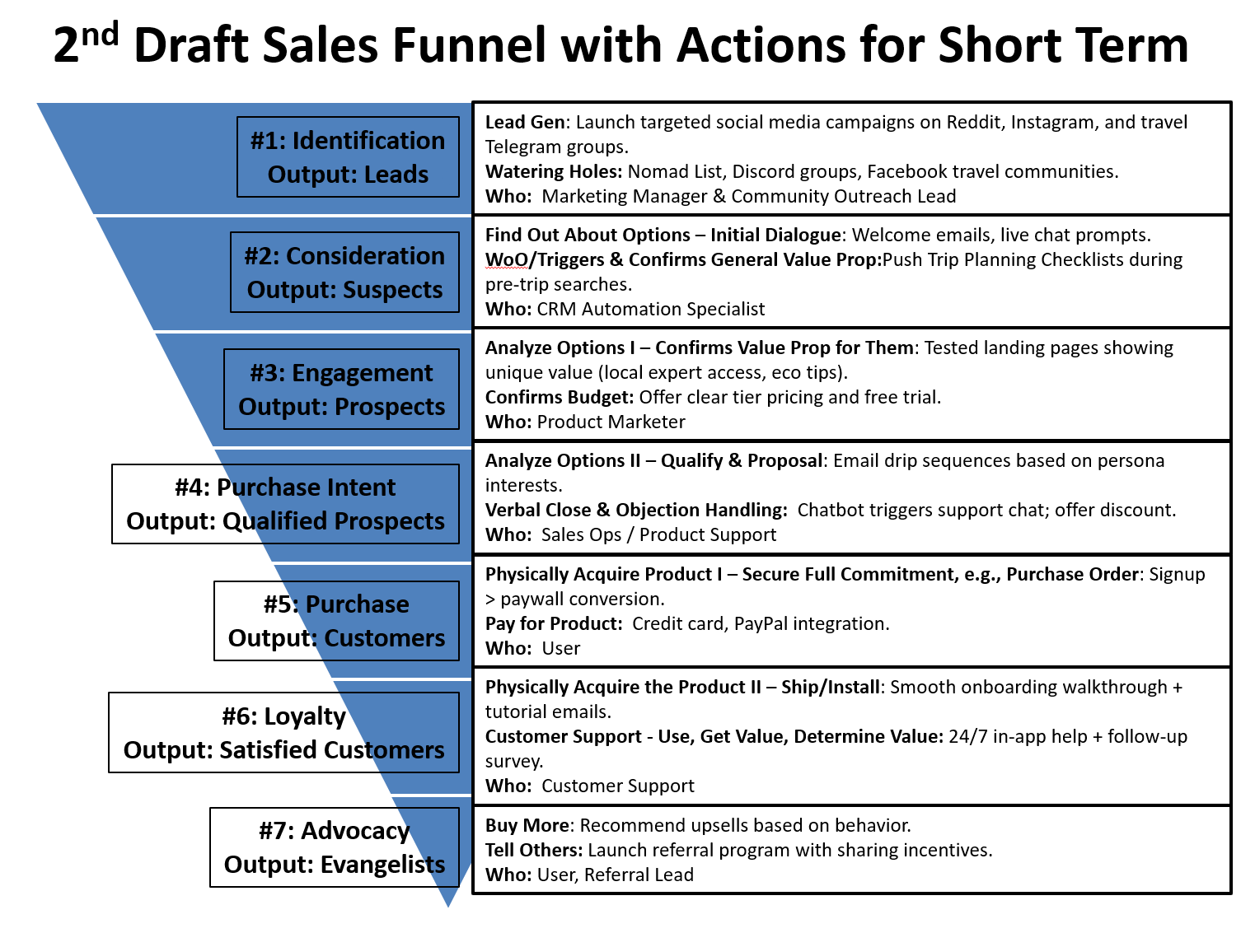

Please describe the major differences between your plans for the short-term and the medium-term sales funnels:

**In the short term, the sales funnel strategy focuses on speed, automation, and leveraging existing digital communities. Lead generation is driven by targeted social media campaigns on platforms like Reddit, Instagram, and Telegram, while engagement occurs through watering holes such as Nomad List and Discord. Initial contact with potential customers is automated, using welcome emails, live chat prompts, and personalized travel checklists to trigger interest. The value proposition is communicated through A/B tested landing pages and a freemium pricing model, allowing users to easily assess the benefits and affordability of the product. Purchase intent is captured using email drip sequences and chatbots, which help guide the user through the final steps of conversion. The purchase process is streamlined through credit card and PayPal payments, while post-purchase support includes in-app tutorials and surveys. Loyalty and advocacy are encouraged through upsell recommendations and a referral program.**

**In contrast, the medium-term sales funnel shifts toward building credibility, personalization, and strategic partnerships to scale outreach. Lead generation evolves to include collaborations with travel bloggers and digital nomad influencers, and engagement is enhanced through virtual events and educational content like downloadable guides. Instead of relying solely on automation, consideration and engagement in this phase incorporate pop-up surveys, social proof from testimonials, and flexible pricing models for specific sub-segments like students. Personalized experience bundles and human-assisted customer service become key during the purchase intent stage, helping address objections and deepen trust. Payment options expand to include tools like Stripe and Google Pay, and support becomes more hands-on with gamified onboarding experiences and dedicated reps for premium users. Advocacy also matures, with community-driven strategies like social media contests and experience sharing to boost organic growth. Overall, the short-term strategy is focused on efficiency and conversion, while the medium-term approach emphasizes depth, trust-building, and personalized customer engagement to support long-term growth.**

Please describe the major differences between your plans for the medium-term and the long-term sales funnels:

**The key differences between the medium-term and long-term sales funnels lie in the shift from personalized growth to scalable enterprise-level operations and advanced technology integration. In the medium-term, the focus is on building trust, engagement, and product flexibility for a broader but still largely consumer-driven audience. Lead generation is achieved through influencer partnerships and virtual events, targeting digital nomads and travel enthusiasts. Customer engagement is personalized through testimonials, flexible pricing, and curated experience packs. Purchase processes remain semi-automated, with options for support from account representatives. Loyalty is encouraged through gamification, and advocacy is fostered through creative community contests like “Tourmate memories.”**

**By contrast, the long-term sales funnel transitions toward enterprise-level partnerships, automation, and global scalability. Identification of leads is driven by strategic alliances with large travel-related organizations like airlines or coworking chains. Customer consideration is powered by AI chatbots with geolocation-based triggers, enabling more predictive and responsive engagement. Engagement becomes more immersive with advanced tech like augmented reality previews or VR tours, and pricing shifts toward corporate and group packages. Purchase intent and acquisition are facilitated by in-platform negotiation tools, white-label partnerships, and API integrations—designed to appeal to B2B clients. Loyalty at this stage is maintained through custom dashboards, service-level agreements, and dedicated account management. Advocacy is driven by invite-only affiliate programs and contract renewals, reflecting the shift to a more structured, long-term client relationship model. Overall, the medium-term is still oriented around high-touch consumer engagement, while the long-term sales funnel focuses on automation, partnerships, and operational scaling, ensuring sustained growth and deeper market penetration.**

### Techniques and Actions to Maximize Yield Rate at Each Stage

|  |  |  |  |
| --- | --- | --- | --- |
| Short Term: Summary of Techniques and Actions to Maximize Yield | | | |
| **Stage in Funnel (starting at top)** | **Technique(s)** | **How to Maximize Conversion** | **Done by Who? When?** |
| #1 – Identification (leads) | **Social media ads, Reddit/Telegram campaigns** | **Targeted messaging, persona-driven content** | **Marketing Manager**  **Month 1–2** |
| #2 – Consideration (suspects) | **Welcome emails, pre-trip checklists** | **Timely nudges, drip campaigns** | **CRM Specialist**  **Month 1–3** |
| #3 – Engagement (prospects) | **Tested landing pages** | **Highlight testimonials and unique features** | **Product Marketer**  **Month 2–3** |
| #4 – Purchase Intent (qualified prospects) | **Email drip and chatbot** | **Real-time engagement, urgency (promo timers)** | **Sales Ops**  **Month 2–3** |
| #5 – Purchase (customers) | **Simple checkout, freemium > premium upsell** | **Eliminate friction in payment flow** | **UX Designer**  **Month 2–3** |
| #6 – Loyalty (satisfied customers) | **Onboarding emails, tutorials** | **Gamify first usage, reward exploration** | **Support Team**  **Month 3** |
| #7 – Advocacy (evangelists) | **Referral program** | **Offer bonus for shares/reviews** | **Community Lead**  **Month 3** |

|  |  |  |  |
| --- | --- | --- | --- |
| Medium Term: Summary of Techniques and Actions to Maximize Yield | | | |
| **Stage in Funnel (starting at top)** | **Technique(s)** | **How to Maximize Conversion** | **Done by Who? When?** |
| #1 – Identification (leads) | **Influencer campaigns, webinars** | **Host monthly online events and giveaways** | **Partnership Manager**  **Months 4–8** |
| #2 – Consideration (suspects) | **Surveys, PDF guides** | **Trigger content downloads pre-trip** | **Growth Hacker**  **Months 5–9** |
| #3 – Engagement (prospects) | **Regional case studies, flexible pricing** | **Create regional landing pages** | **Product Marketing**  **Months 6–12** |
| #4 – Purchase Intent (qualified prospects) | **Custom itineraries, support chat** | **Train support for common objections** | **Account Rep**  **Months 7–12** |
| #5 – Purchase (customers) | **Stripe, Google Pay, App Store, package bundles** | **Add urgency via seasonal discounts** | **Product and Finance**  **Months 6–12** |
| #6 – Loyalty (satisfied customers) | **Gamification, community group invites** | **Build progression-based perks** | **CX Team**  **Months 7–12** |
| #7 – Advocacy (evangelists) | **Travel memory contest, newsletter highlights** | **Showcase top users publicly** | **Community Manager**  **Month 10+** |

|  |  |  |  |
| --- | --- | --- | --- |
| Long Term: Summary of Techniques and Actions to Maximize Yield | | | |
| **Stage in Funnel (starting at top)** | **Technique(s)** | **How to Maximize Conversion** | **Done by Who? When?** |
| #1 – Identification (leads) | **Airline/coworking partnerships, expos** | **Bundle trials with partners** | **Biz Dev Team**  **Year 2+** |
| #2 – Consideration (suspects) | **AI-driven chatbots, location triggers** | **Trigger offers based on movement** | **AI/ML Team**  **Year 2+** |
| #3 – Engagement (prospects) | **VR/AR previews, corporate plans** | **Offer demo kits to enterprise clients** | **Enterprise Sales**  **Year 2+** |
| #4 – Purchase Intent (qualified prospects) | **In-platform proposal & negotiation** | **Simplify legal review flows** | **Legal and Sales**  **Year 2+** |
| #5 – Purchase (customers) | **API integration, enterprise invoicing** | **Offer post-trial invoicing** | **Product and B2B Sales**  **Year 2+** |
| #6 – Loyalty (satisfied customers) | **Account managers, SLA guarantees** | **Assign reps to VIP clients** | **Customer Success**  **Year 2+** |
| #7 – Advocacy (evangelists) | **Affiliate programs, renewals** | **Exclusive partner rewards** | **Enterprise Ops**  **Year 3+** |

### Risk Factors

What are your three biggest risk factors in your go-to-market plan? How do you intend to mitigate those risks? What metrics will you use to monitor them and intervene as needed? (Remember, things never go exactly the way you want them to or you plan them!)

1. Risk Factor #1 and Mitigation Plan:

**Low conversion rate from freemium to paid users could hinder early revenue generation and slow down growth.**

**Implement A/B testing across onboarding flows, emphasize time-limited benefits for early upgrades, and offer introductory discounts to test willingness to pay.**

Metrics to Watch:

**Conversion rate from free to paid users within the first 7–14 days, user drop-off during onboarding, and engagement frequency during the first week.**

Potential Intervention Strategy:

**If conversion falls below 5%, test new value bundles or unlock premium features for limited-time trials; engage power users directly for feedback on pricing and feature relevance.**

1. Risk Factor #2 and Mitigation Plan:

**High user churn after the first month could limit recurring revenue and weaken long-term viability.**

**Enhance user retention through gamified onboarding, loyalty incentives, and hyper-personalized experience recommendations post-trip.**

Metrics to Watch:

**Monthly retention rate, NPS (Net Promoter Score), and number of experiences booked per user within 30 days.**

Potential Intervention Strategy:

**If churn exceeds 40%, introduce engagement campaigns with personalized trip suggestions, improve customer support response times, and launch in-app surveys to collect direct feedback for product iteration.**

1. Risk Factor #3 and Mitigation Plan:

**Lack of community-driven advocacy could weaken referral-based growth and reduce organic reach.**

**Launch structured referral programs and incentivize user-generated content via contests and highlights within the app.**

Metrics to Watch:

**Referral activation rate, number of social shares and reviews per 100 users, and user-generated content submissions.**

Potential Intervention Strategy:

**If referral engagement is low, collaborate with micro-influencers, showcase user testimonials prominently, and offer tiered rewards for referrals and social engagement.**

## Example

GearUp was a class project by Anusha Paliwal, Jillian Ardrey and Monique Guimond, all MIT Sloan MBAs from the class of 2017. They are all avid outdoors types, and they developed a plan for a new venture that would offer an annual subscription service to provide active young traveling professionals with high-quality ski, snowboard, camping and backpack gear delivered to them when they went on vacations. Here is how they explained how they would maximize conversion between stages of the funnel, and how they defined their milestones for moving from the short term to medium term to long term sales strategies.

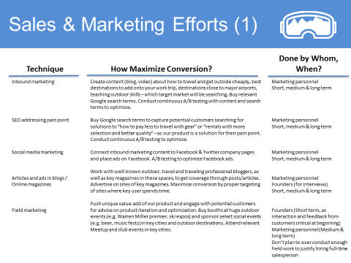

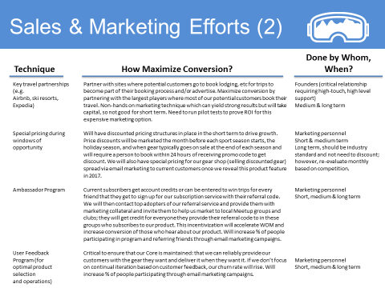

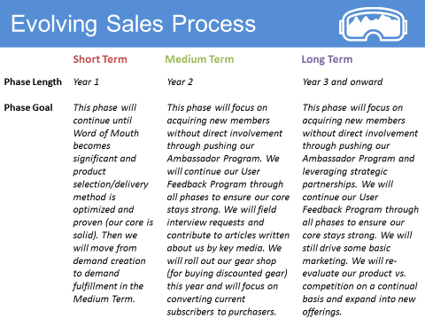

This has been another intense chapter but you are building up great knowledge of your business so not only you know if it is worth doing but you also have a plan to make it great. Just as importantly, you are understanding the underlying drivers so you can intelligently and quickly identify and make adjustments once the business starts. It is hard work but it will pay off. The only thing harder is trying to launch a new product and not having a good plan. That is not only more work in the end, it is much more frustrating. Hang in there, we are about to pull it all together and launch this rocket ship.